

Bahrain Polytechnic
IT8416 – Data Mining
Project Report
Financial Technology Sector
Bitcoin Next-Day Price Direction Prediction
Field | Details
Project Title | Bitcoin Next-Day Price Direction Prediction
Course Code | IT8416
Course Title | Data Mining
Section | 001
Group No | 3
Submission Date | 3rd June 2026

Group Members
# | Student Name | Student ID | Role
1 | Abdulla Murad | 202302258 | Data Scientist
2 | Mishal Alaraibi | 202301287 | Data Mining Engineer
3 | Hood Alabbasi | 202300629 | Data Analyst
4 | Ahmed Alansari | 202304215 | Data Analyst / Coordinator

Table of Contents
Table of Contents 2
Task 1 – Problem Statement Formulation and Definition 3
Motivation 4
Objectives 4
Problem Statement / Project Definition 4
Expected Result 4
Task 2 – Selection of an Appropriate Data Set 4
Source of Dataset 5
Dataset Description 5
Attributes Used 5
Initial Data Visualisation & Distribution 5
Task 3 – Preparation and Pre-processing of Selected Data 7
Missing & Redundant Data Handling 8
Create Binary Direction Column 8
Replace missing values 11
Categorial Columns 13
Normalization 13
Remove correlated attributes 15
Applying PCA 16
Cumulative PCA variance 18
Outlier Detection 19
Before vs After – Inference 20
Task 4 – Building Data Mining Models 20
Technique Justification & Data Split 21
Model 1 – Decision Tree 22
Model 2 – k-Nearest Neighbours 23
Ensemble – Random Forest 25
Task 5 – Evaluating Data Mining Models 26
Metrics Used & Justification 27
Model 1 Evaluation – Decision Tree 27
Model 2 Evaluation – k-NN 27
Model 3 Evaluation – Random Forest 27
Models comparison with Bar Chart 28
Confusion Matrices 28
Interpretation 29
Task 6 – Inferences, Recommendation and Reflection 30
Compare & Contrast Models 30
Inferences / Insights 30
Recommendations (Scope of Work) 31
Reflection 31
References 31
Appendix 32

Task 1 – Problem Statement Formulation and Definition

Motivation
Bitcoin is the biggest force in the cryptocurrency market. Its price is volatile and can move highly throughout the day. Traders, fintech firms, and risk managers face both potential gain and danger due to these swings. Even a slight advantage in predicting where prices move tomorrow can be very valuable, since the timing of decisions depend heavily on that information. As pass prices and trading volumes are widely available in machine-readable formats researchers are likely to look for methods to find all types of patterns. The main goal is to spot consistent signals that could help indicate future movements.

Objectives
- To develop data mining models that predict whether the next trading day's Bitcoin price will go up or down using technical indicators and historical market data.
- To test and compare at least two separate classification techniques and an ensemble model, to see which works best for this problem.
- Analyze which features have the most influence on short-term Bitcoin direction and evaluate how reliably it can be predicted.

Problem Statement / Project Definition
Given historical Bitcoin market data (open, high, low, close, volume, market capitalization) along with derived technical and blockchain indicators, the objective is to find whether it is possible to mine and use those features to classify if the next trading day’s closing price will rise or fall. The study also aims to identify which feature and model best capture this directional signal.

Expected Result
We expect to develop a trained classifier (or ensemble model) that predicts whether Bitcoin’s price will move up or down the next day. The model’s performance is compared against a simple majority class baseline using directional accuracy and confusion matrices. Features and variance analysis will also be used to identify the main factors influencing predictions and to better understand the limits of short-term bitcoin forecasting.

Task 2 - Selection of an Appropriate Data Set

Source of Dataset
The data is taken from the public Kaggle dataset “Cryptocurrency Historical Prices” (referenced by the Topic 9 research notebook). Two files were used: bitcoin_price.csv, which contains daily Open, High, Low, Close, Volume and Market Cap for Bitcoin, and bitcoin_dataset.csv, which provides daily blockchain network metrics such as hash rate, mining difficulty, miners’ revenue and number of transactions. The price dataset was selected because it offers a clean, complete daily OHLCV history of Bitcoin, while the blockchain dataset was merged to include additional non-price variables that can provide predictive value beyond market movements alone.

Dataset Description
Property | Value
Raw daily prices | 1592 days (28-04-2013 to 05-09-2017)
Instances after feature & cleaning | 674 (≥ 250 required)
Total attributes after adjustment | 21 (≥ 8 required)
Attribute types | Quantitative (price, volume, indicators) + categorical label (Direction)
Target variable | Direction — Up (1) vs Down (0), next-day close
Class balance | Up: 373 | Down: 301

Attributes Used
Six base attributes (Open, High, Low, Close, Volume, Market Cap) were expanded into a more detailed feature set, including daily return, high–low range, moving averages (MA7, MA14, MA30), 7-day volatility, volume change, lagged closes, RSI(14), MACD, along with four merged blockchain metrics (hash rate, difficulty, number of transactions, miners’ revenue). The target variable, Direction, is 1 if the next day’s closing price is higher than today’s close, otherwise 0.

Initial Data Visualisation & Distribution
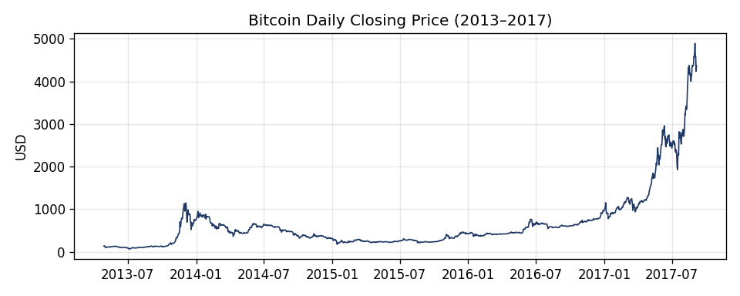
Figure 2.1 - Bitcoin daily closing price (2013–2017). The series shows long quiet periods followed by a sharp 2017 run-up, illustrating strong non-stationarity and volatility clustering.
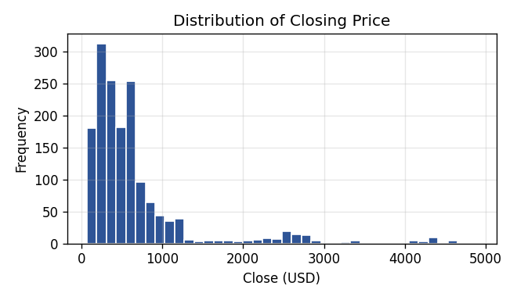
Figure 2.2 - Distribution of closing price: heavily right-skewed, with most days at low prices and a long tail from the 2017 rally.
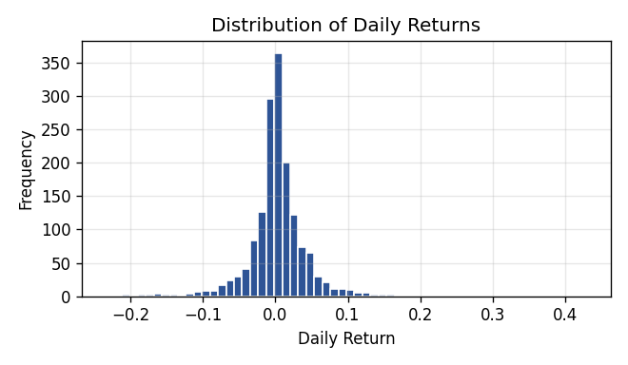
Figure 2.3 - Distribution of daily returns: roughly centred on zero but with fat tails (large up and down days), typical of crypto markets.
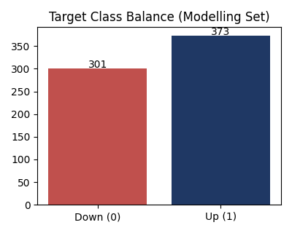
Figure 2.4 - Target class balance. Up days slightly outnumber Down days, so the majority-class baseline is the reference any model must beat.
Comment on distribution: price levels are non-stationary and strongly right-skewed, whereas returns are more centered and roughly symmetric with heavy tails. There is also a mild class imbalance (more Up than Down days) which means accuracy on its own is not enough to properly evaluate model performance.

Task 3 - Preparation and Pre-processing of Selected Data
Pre-processing is the most time-consuming stage of the KDD process and was carried out in the following sequence: data selection → cleaning → transformation/feature engineering → redundancy removal → normalisation → dimensionality reduction (PCA) → ready-for-mining dataset.
Note: When importing the data make sure to do the following for the model to run:
1.change the date type to polynominal
2. And to the furthest right change the Direction type to binominal

Missing & Redundant Data Handling
The raw Volume column contained '-' placeholders in the earliest dates, while the rolling/lag features and merged blockchain columns introduce missing values at the beginning of the time series. These incomplete rows were removed, reducing the data from 1592 raw days to 674 complete observations. Still plenty though, more than the 250-instance requirement. Redundancy was then addressed using a correlation matrix (Figure 3.1), where highly correlated pairs with |r| > 0.95 were considered redundant and one of each highly correlated pair was removed. This step reduced the feature set from 21 attributes to 11.

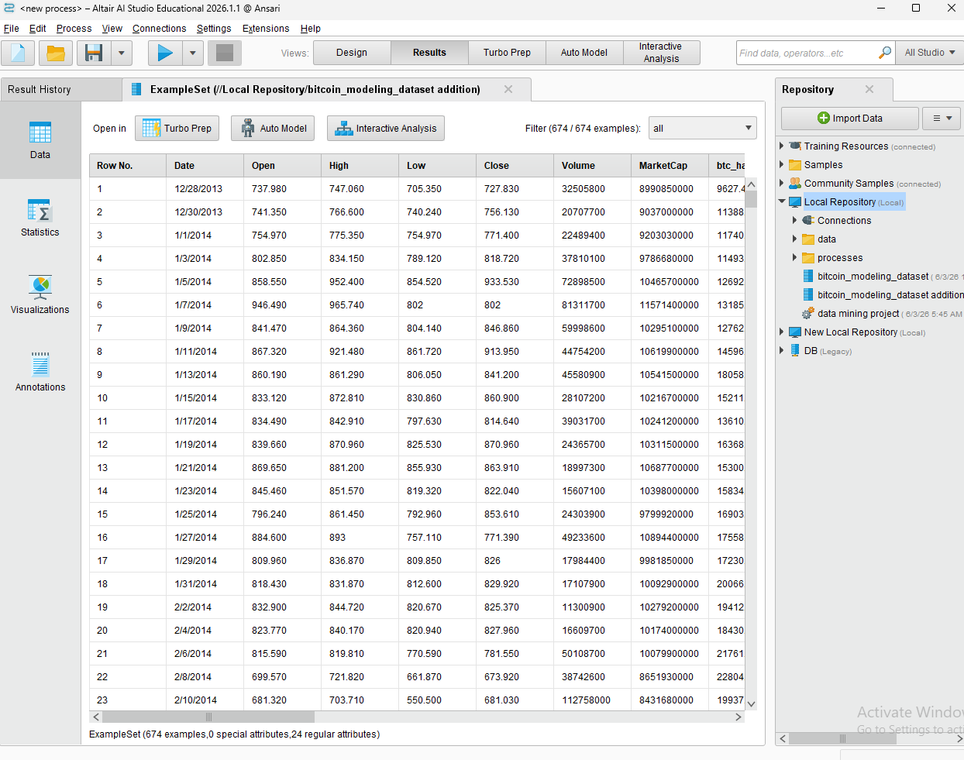
Create Binary Direction Column
When adding the dataset to AI studio, we selected the direction column, changed its data type to a dropdown, and set it as binomal.

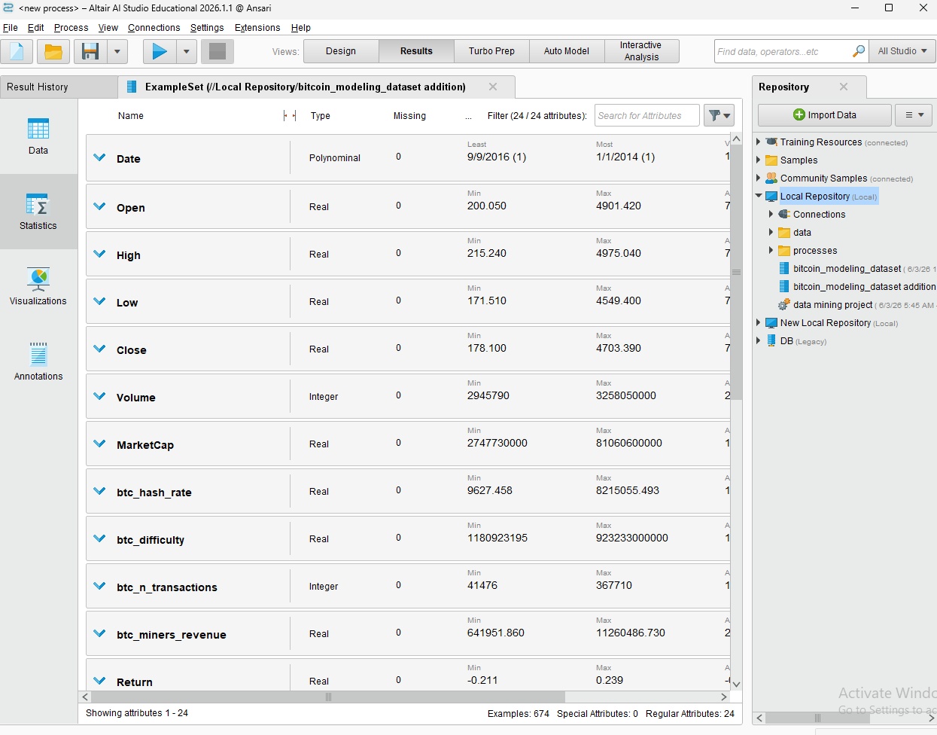

We removed these attributes as redundant: Close, Close_lag1, Close_lag2, High, Low, MA14, MA30, MA7, MarketCap, btc_difficulty. These are dropped because absolute price levels (Close, lags, moving averages, market cap, difficulty) are almost perfectly correlated with one another; keeping one representative avoids multicollinearity.

Set roles:
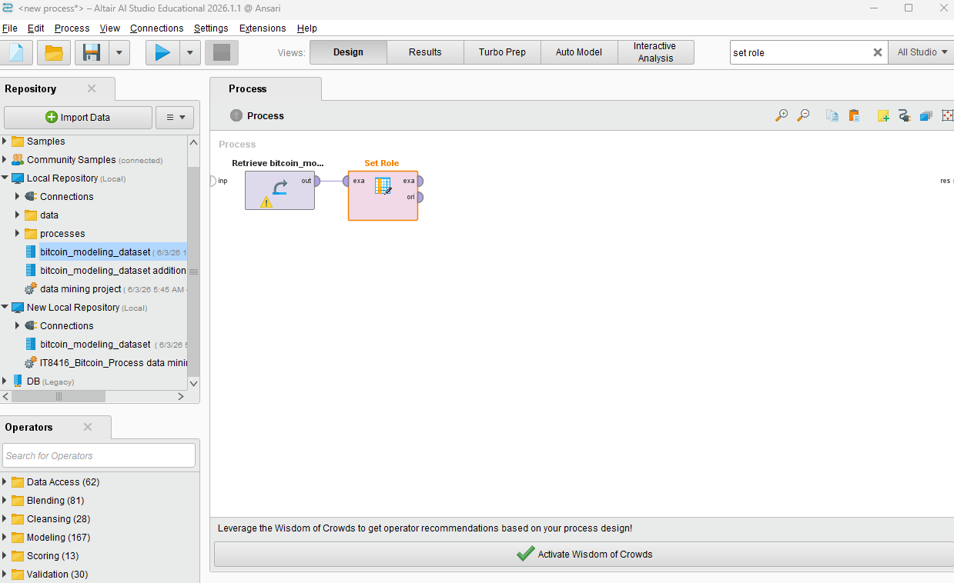
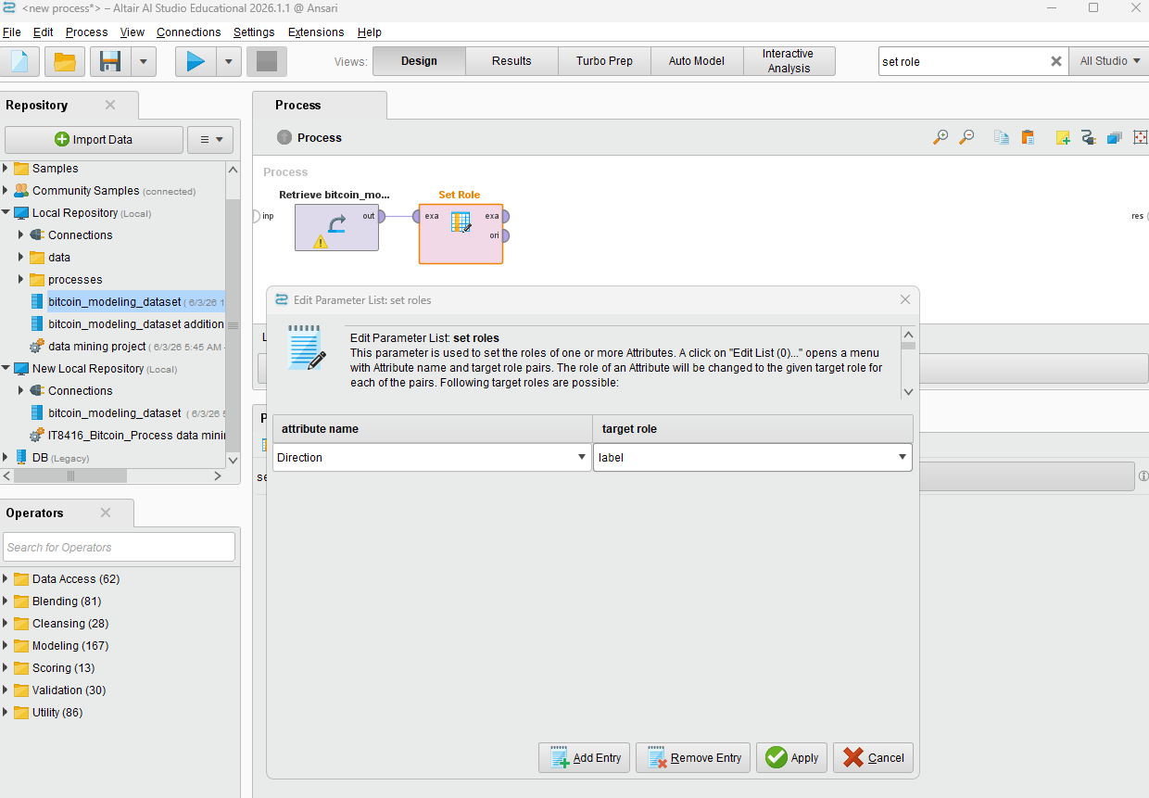
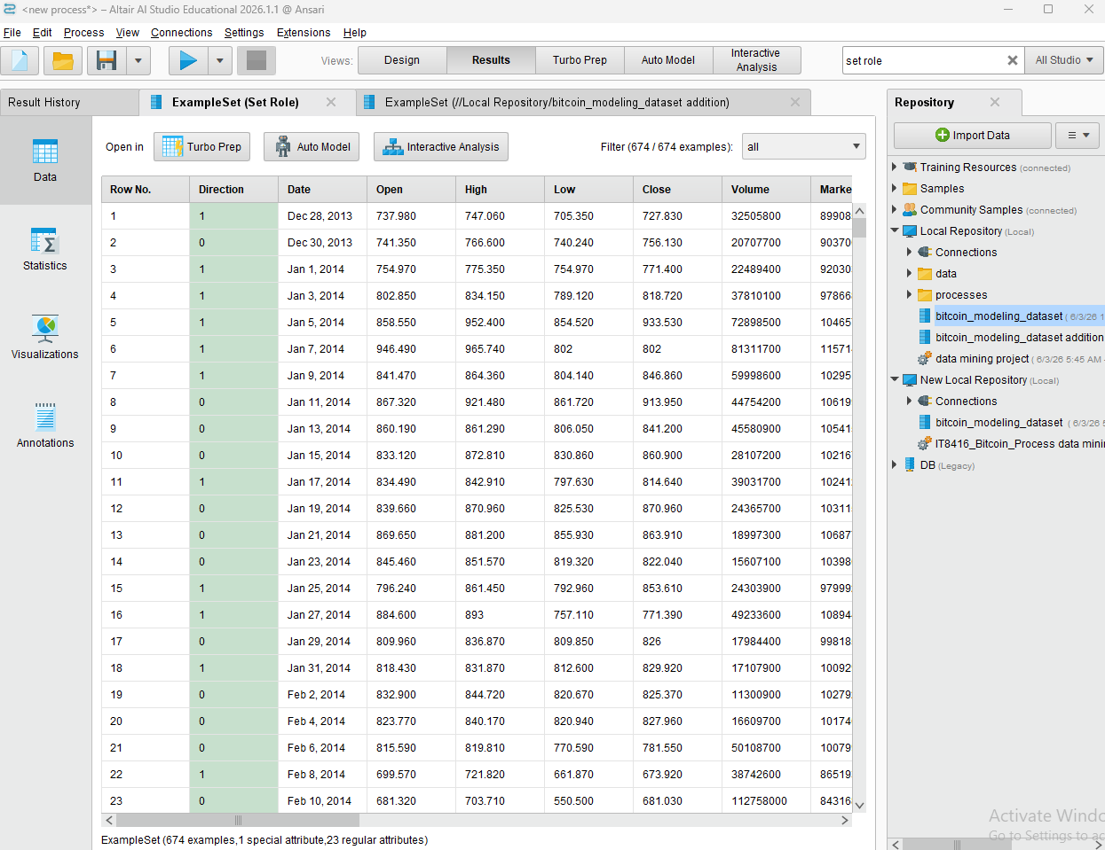

Replace missing values
To ensure data quality and maintain data integrity, the Replace Missing Values operator was applied in RapidMiner. This crucial step prepared the dataset for subsequent modeling stages. Missing values were then Imputed across two different data types:
- Categorical Columns: Handling missing text-based or classified variables.
- Numerical Columns: Addressing missing quantitative or continuous metrics.

we can do that by using “Replace missing values”

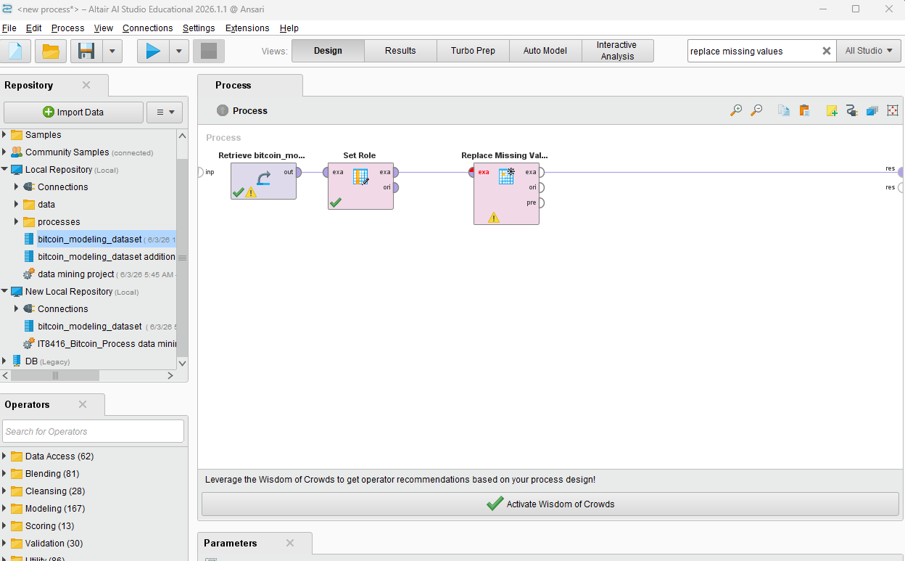

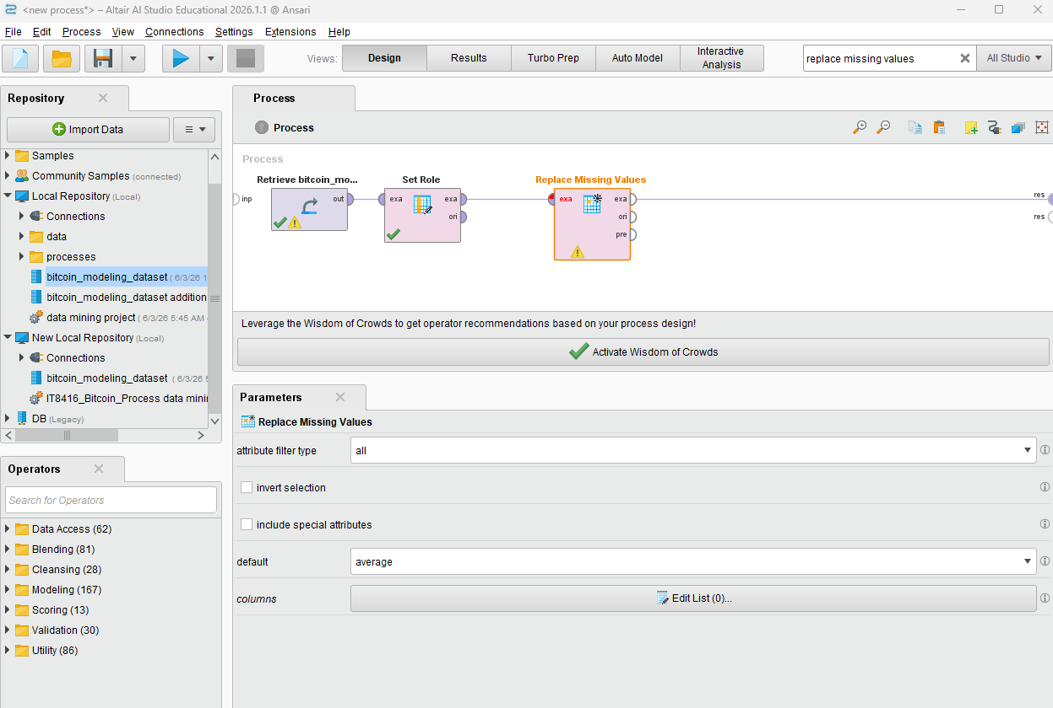
The parameters will be:
Attribute filter type: all
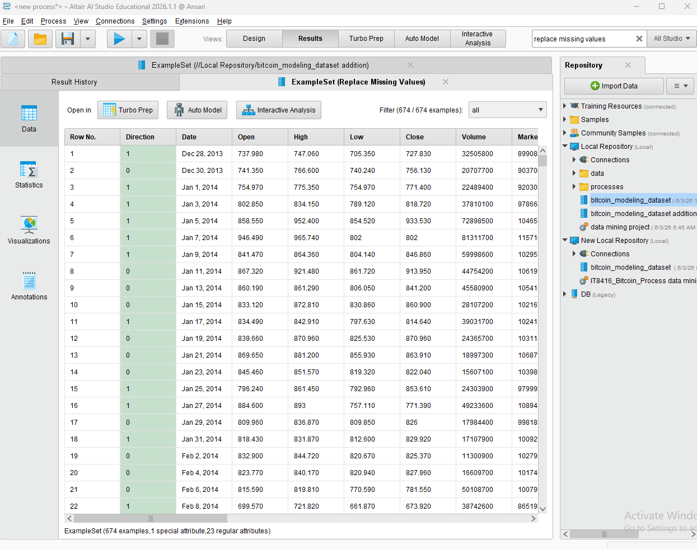
Default: Average

For our Bitcoin dataset, the Replace Missing Values operator handled columns according to their data type. For the categorical Direction column, missing values were replaced with the most frequent value (mode). For numerical financial features, including Close, Open, High, Low, and Volume, missing entries were filled using the column mean. This ensured the dataset remained consistent and complete, avoiding any errors in later steps such as normalization and PCA.

Categorial Columns
In the data set, the dates were shown with text and slashes and we should convert this from nominal to numerical. We did that by adding one more set role with the attributes:
Attribute name: Date
Target role: id
This changed the date to numerical.

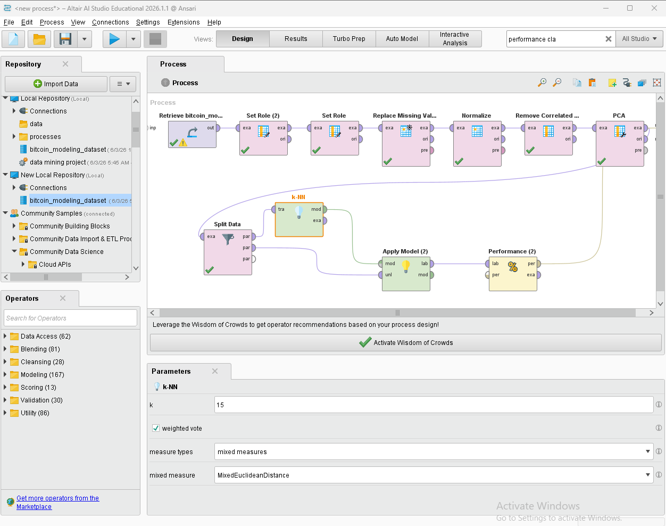

Normalization
Following data cleansing, the Normalize operator was applied to standardize all numerical financial metrics within our Bitcoin dataset, using the Z-transformation (Standard Scaler) method. This process transformed columns such as Close, Open, High, Low, and Volume so that each feature has a mean of 0 and a standard deviation of 1. Scaling these attributes is a critical prerequisite because Principal Component Analysis (PCA) is highly sensitive to the varying magnitudes of raw numbers; without normalization, high-volume values would disproportionately dominate the variance calculations over smaller price fluctuations.

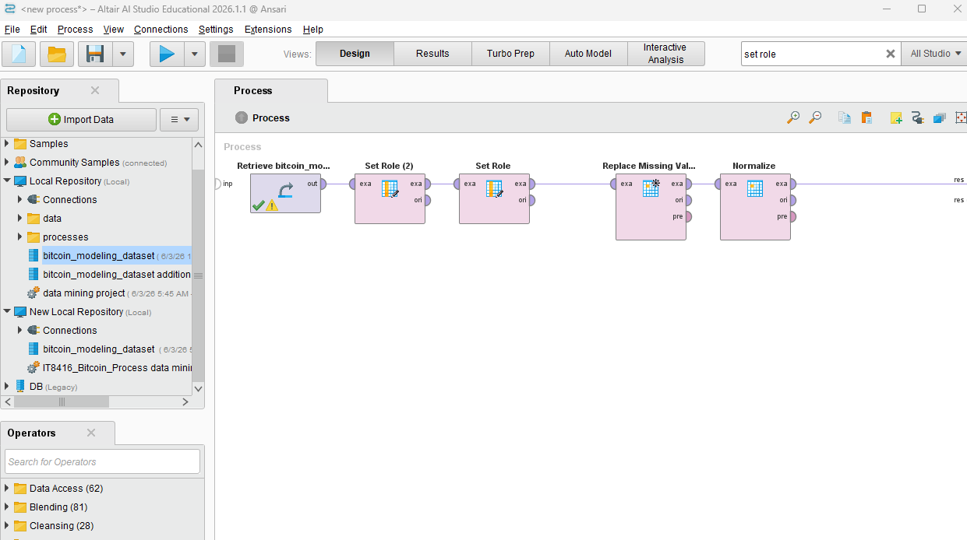
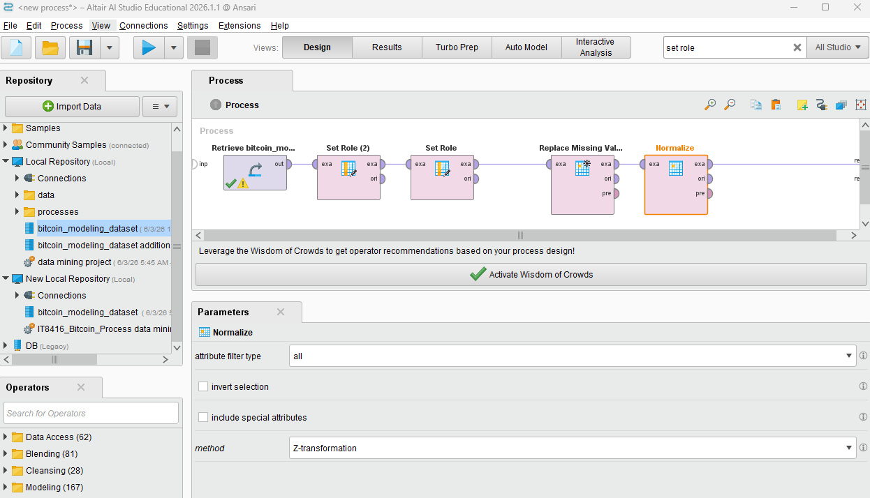
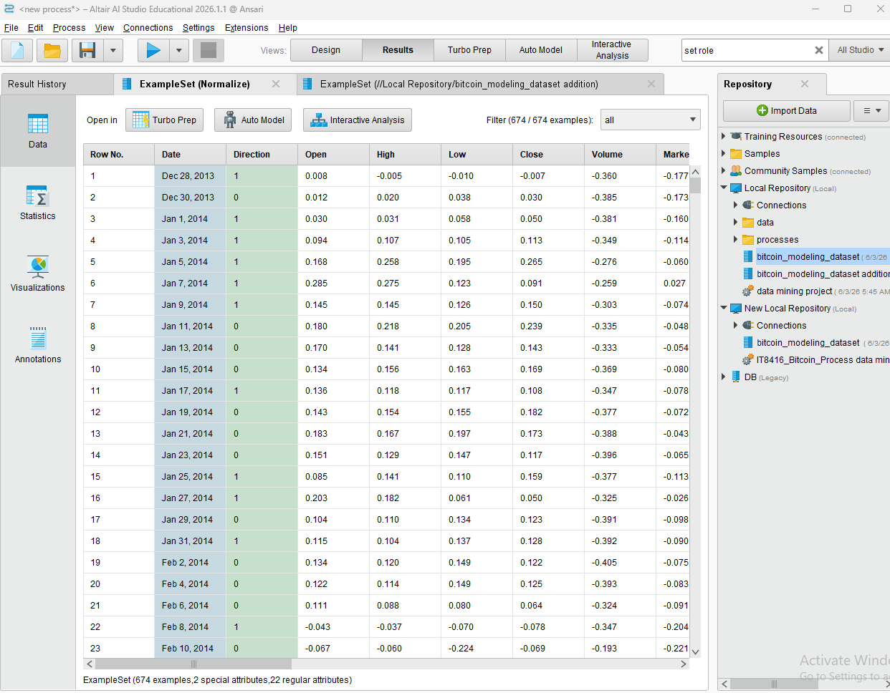

Remove correlated attributes
Prior to running the PCA, the Remove Correlated Attributes operator was applied to address the issue of multicollinearity within our Bitcoin dataset. Financial indicators especially trading metrics like High, Low, Open, and Close prices tend to be highly correlated with one another, moving together almost identically. By establishing a correlation threshold, this operator automatically identified and filtered out these heavily redundant columns. Removing features that are correlated at this stage reduces redundancy in the data and it also helps to prevent models avoid a repeated price pattern, and makes sure that the learning algorithms focus on the most distinct and informative signals in the dataset

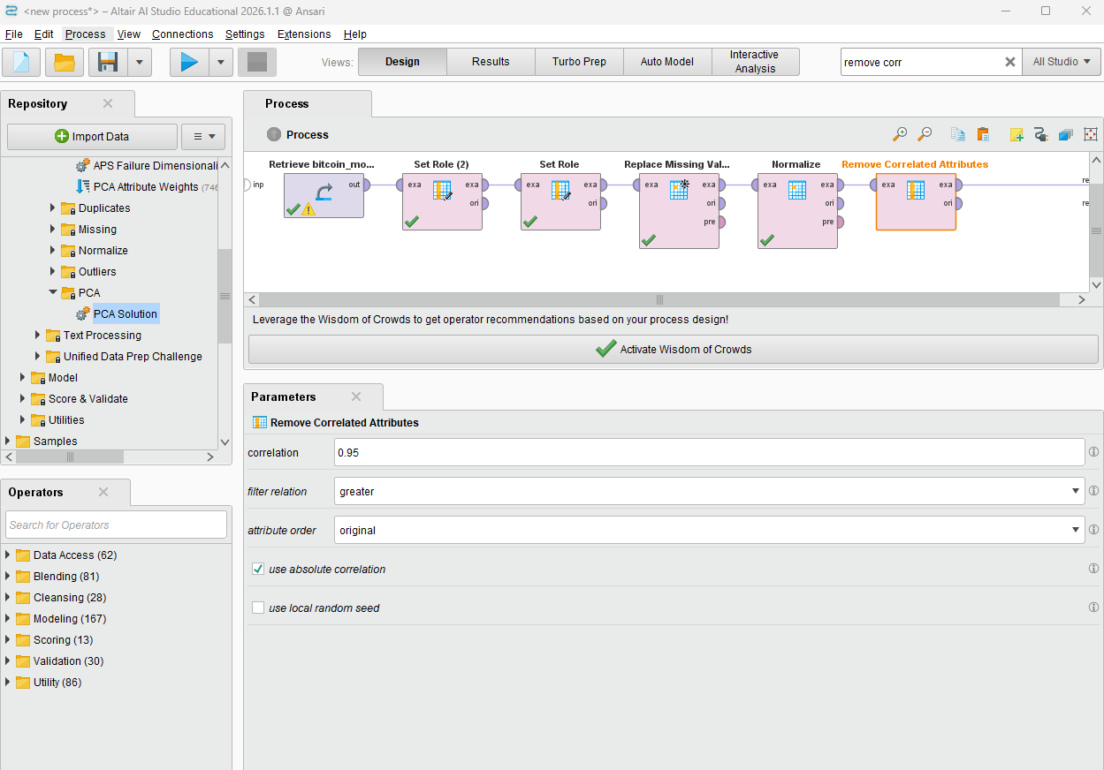
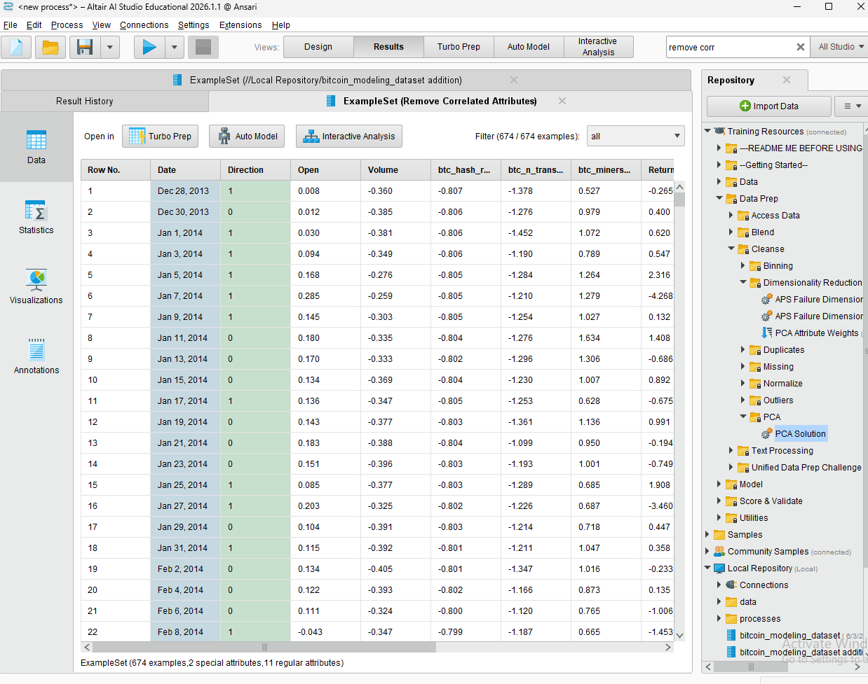

Applying PCA
We implemented the PCA (Principal Component Analysis) operator to reduce the dimensionality of our Bitcoin dataset. We set the operator with a variance threshold of 0.95. This choice was made to balance between the model’s reducing complexity and to preserve the important financial signals. This process compressed our many financial indicators down to two principal components, which eliminated redundant dimensions and columns while preserving the data needed to have accurate market direction analysis. Removing these dimensions will prevent overfitting and will improve the generalization performance of the predictive models.

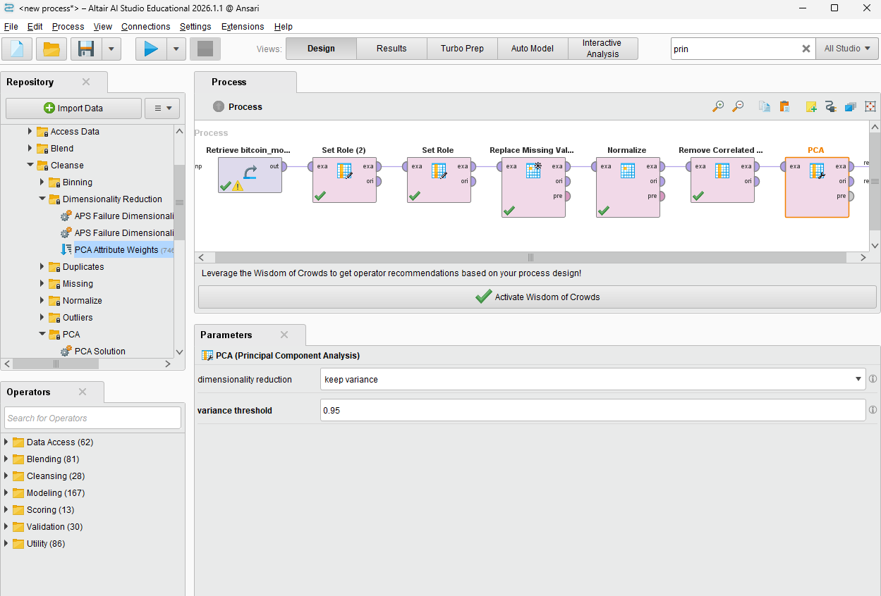
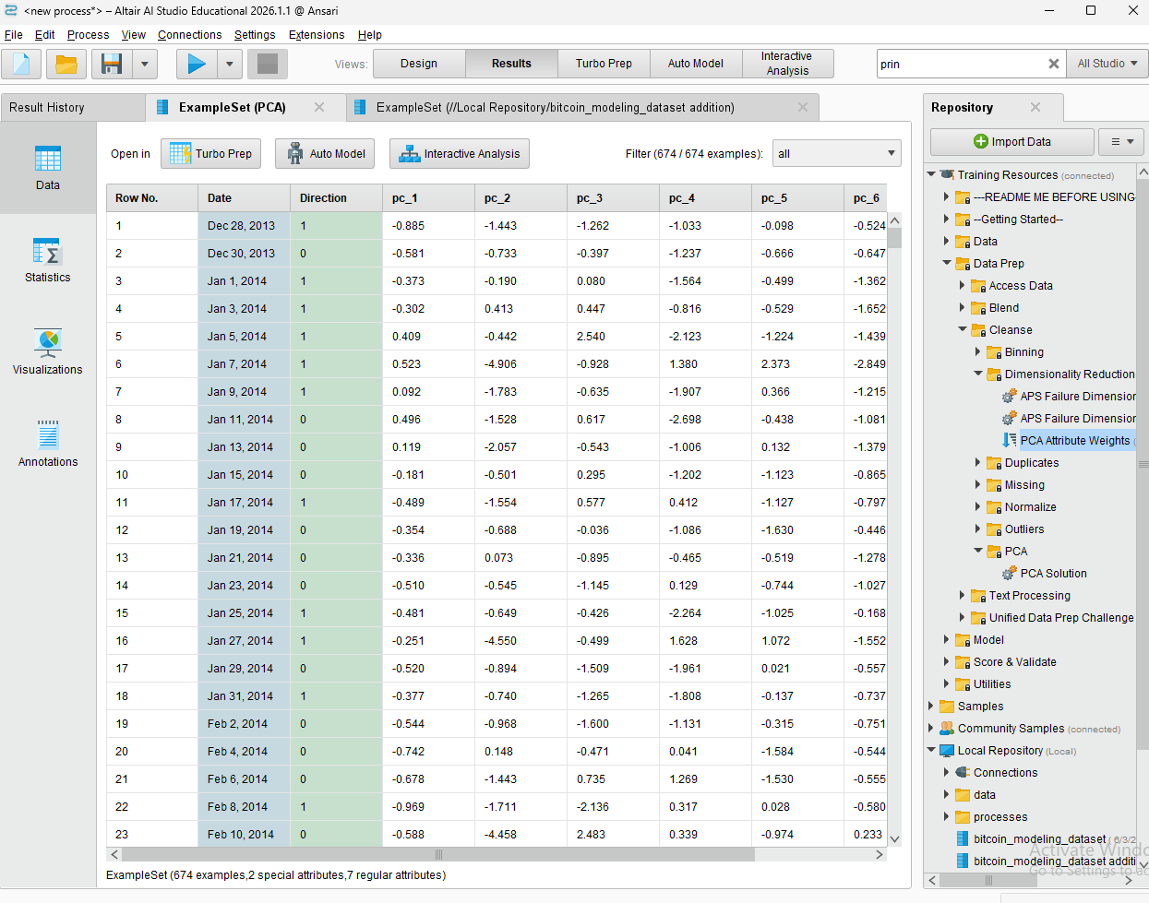

Cumulative PCA variance
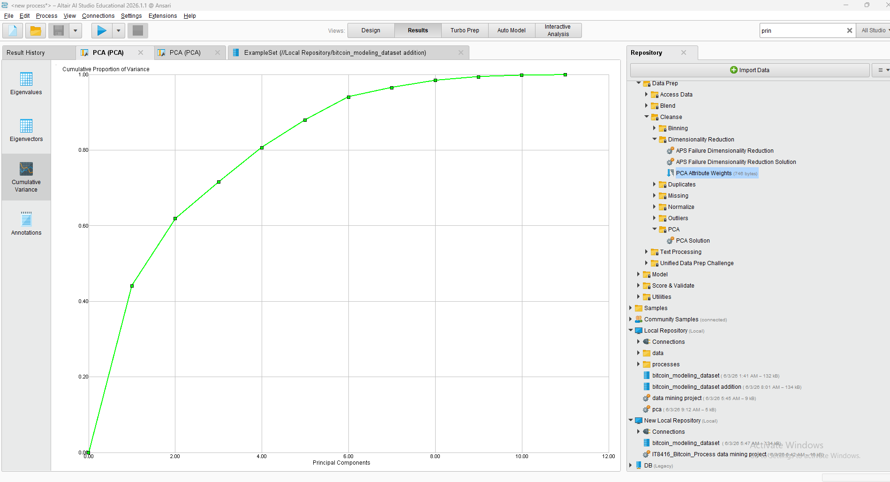

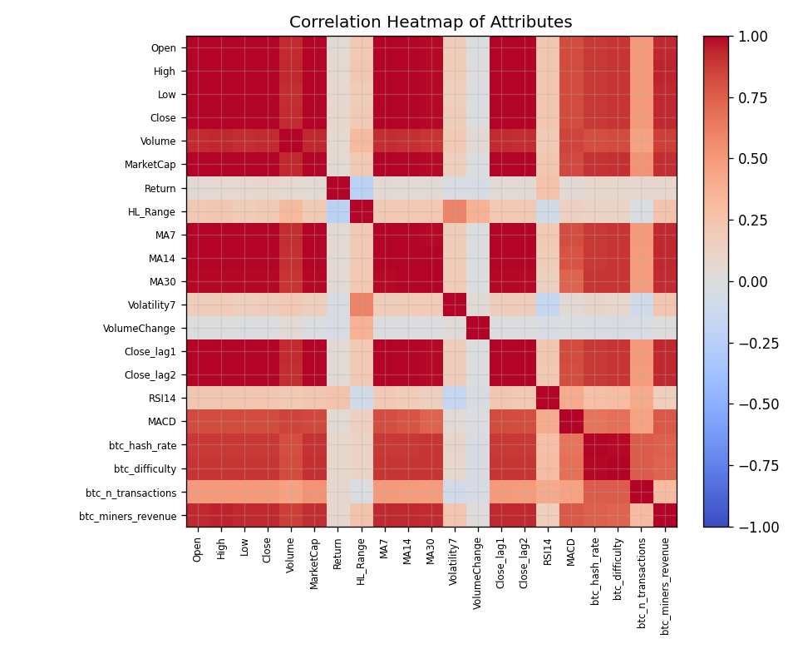

Figure 3.1 - Correlation heatmap. The bright block among price-level attributes confirms heavy redundancy, justifying their removal before modelling.

Outlier Detection
Box plots of return, high-low range, and 7-day volatility (Figure 3.2) reveal numerous extreme points. Rather than deleting them, these outliers were retained: in crypto markets extreme daily moves are genuine, information-rich events, not data errors, and removing them would discard exactly the volatility the model needs to learn.

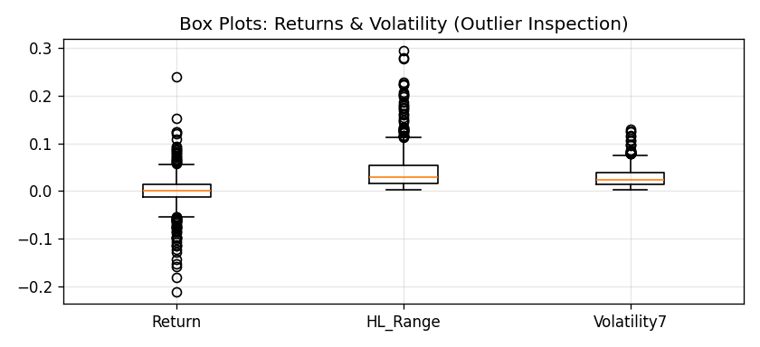

Before vs After - Inference
Before pre-processing, the data was redundant, unscaled and high-dimensional; after pre-processing it is clean, standardized and compressed to a small set of decorrelated components.

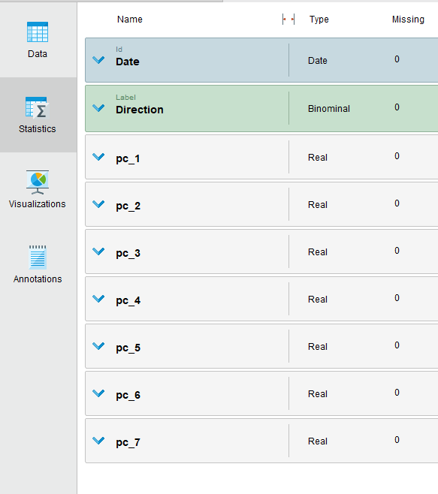


Task 4 - Building Data Mining Models

Technique Justification & Data Split
This is a supervised binary classification problem, so we can use classification techniques. Since the data is a time series, we went with a chronological 70/15/15 split for train/validation/test sets. We did this because including future data in training would make the results unrealistic.

The model learned from the first 572 instances and then we evaluated it on the final 102. We stuck to the 70% mark for training and the rest for testing to prevent biased evaluations.
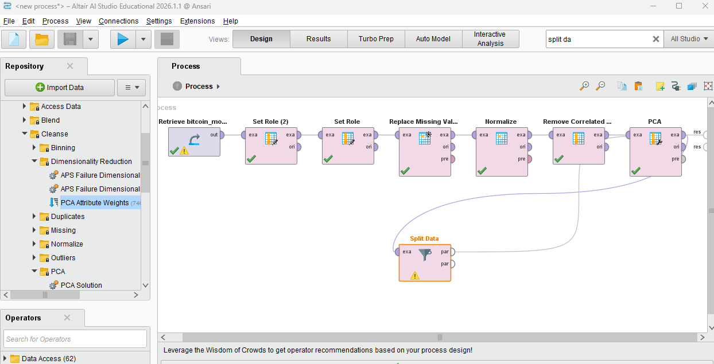
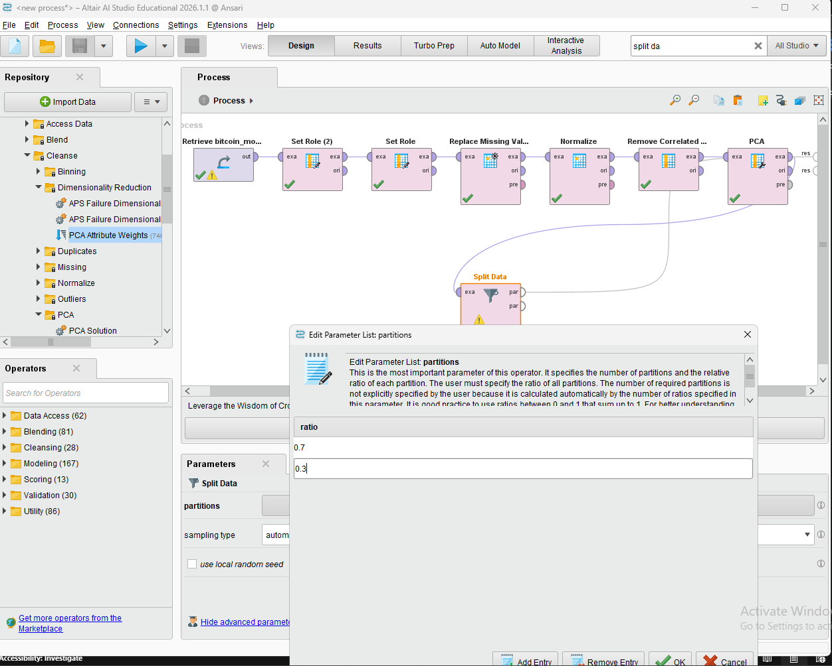

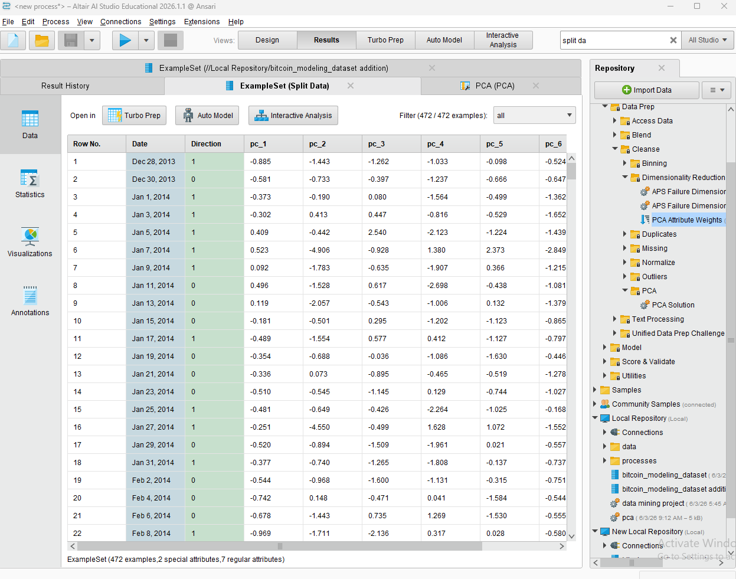

Model 1 - Decision Tree
A pruned Decision Tree Parameters:(max depth 5, minimum 20 samples per leaf) was built first because it is highly interpretable it shows which factors it splits on and provides a clear benchmark. Equivalent in RapidMiner: the Decision Tree operator; in R: rpart.
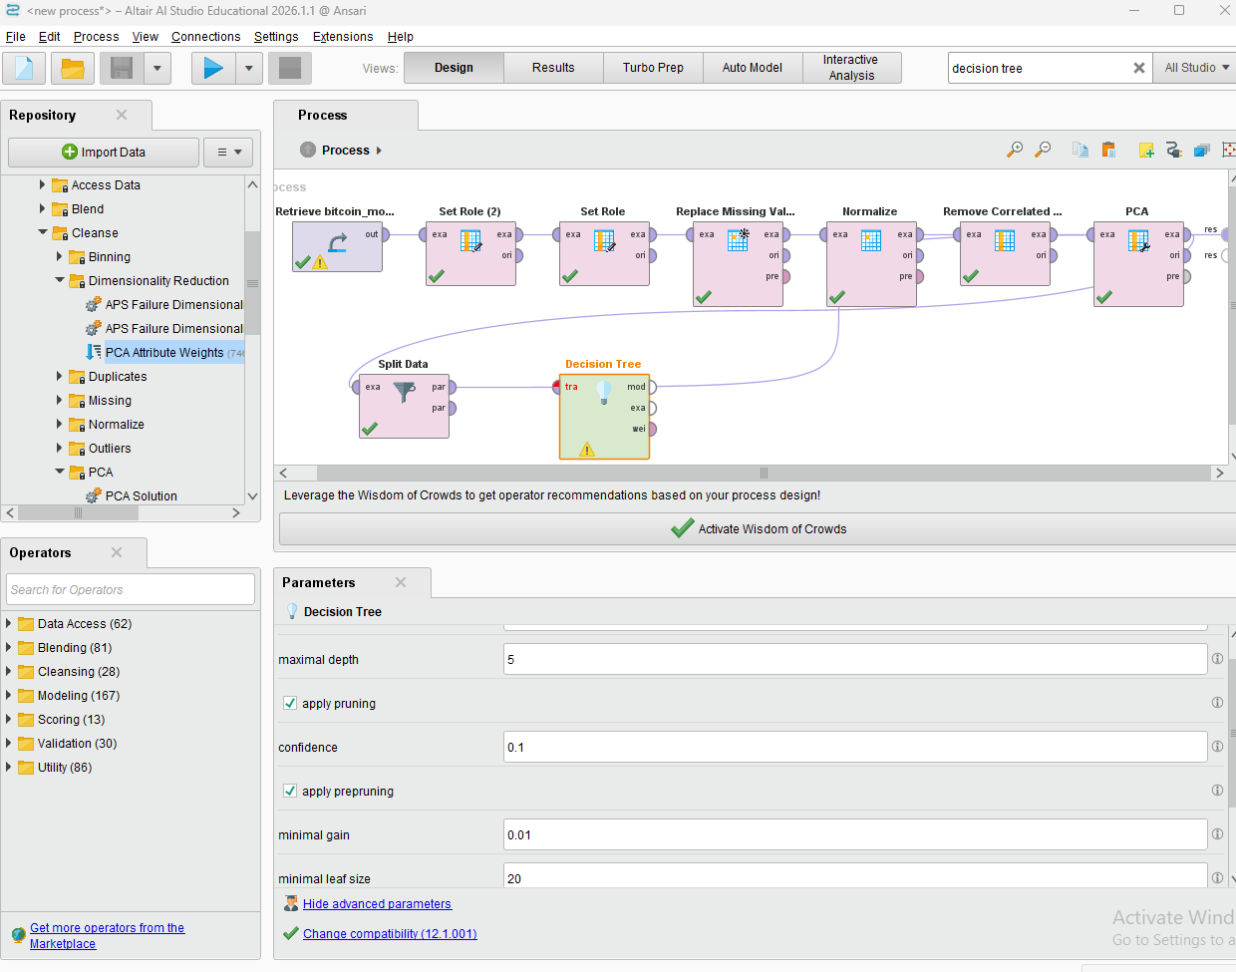

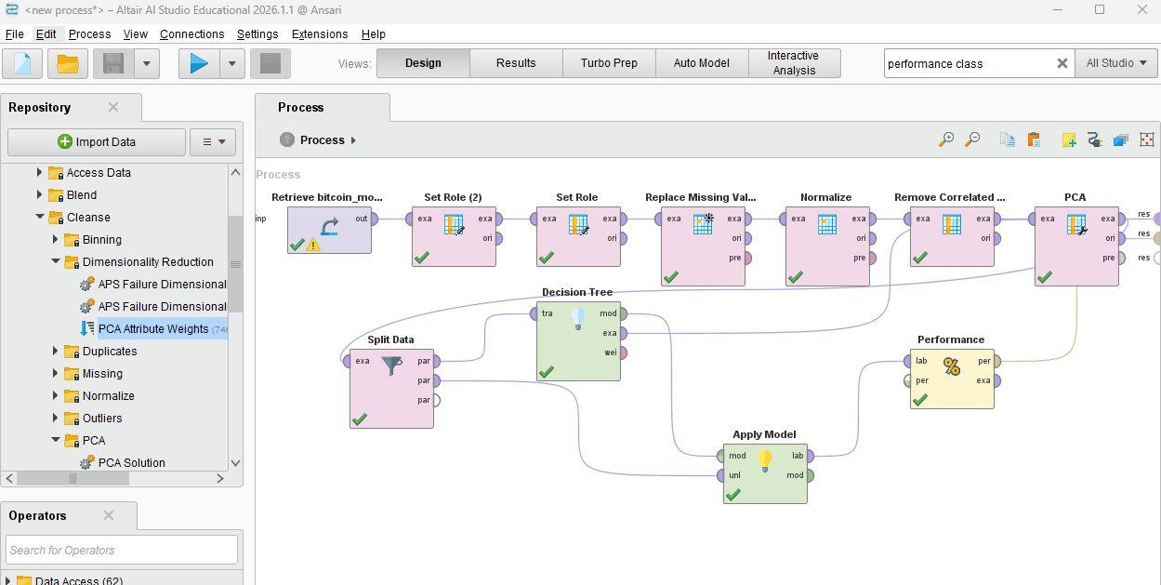

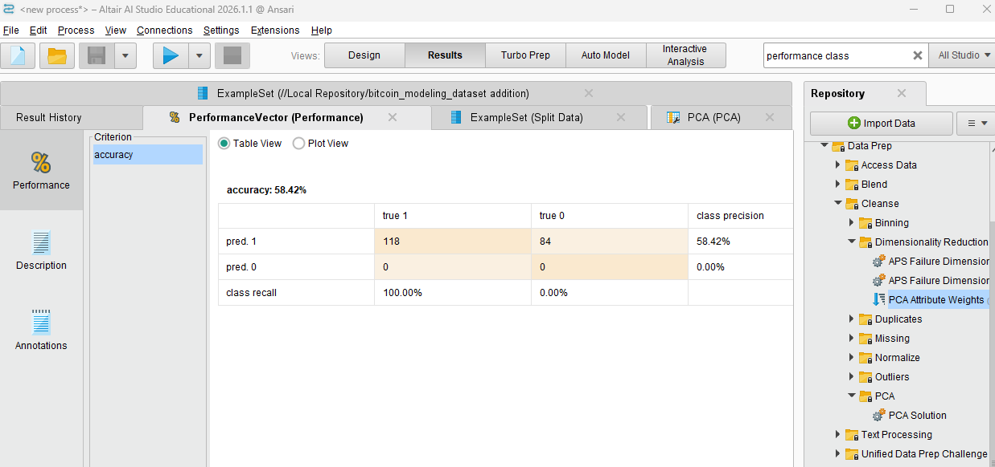

We connected the split data to the decision tree and the apply model. Next, we connected the decision tree to the apply model. Then, we connected the apply model to the performance and the performance to the “res”

Model 2 - k-Nearest Neighbours
k-NN parameters:(k = 15) represents a completely different, distance-based paradigm and works directly on the standardised PCA components. It makes no assumption about decision-boundary shape, providing a useful contrast to the tree.
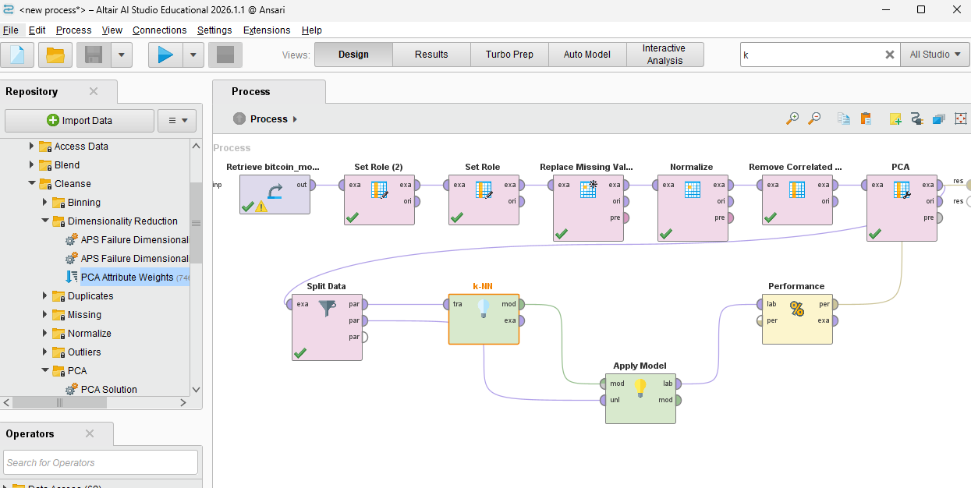
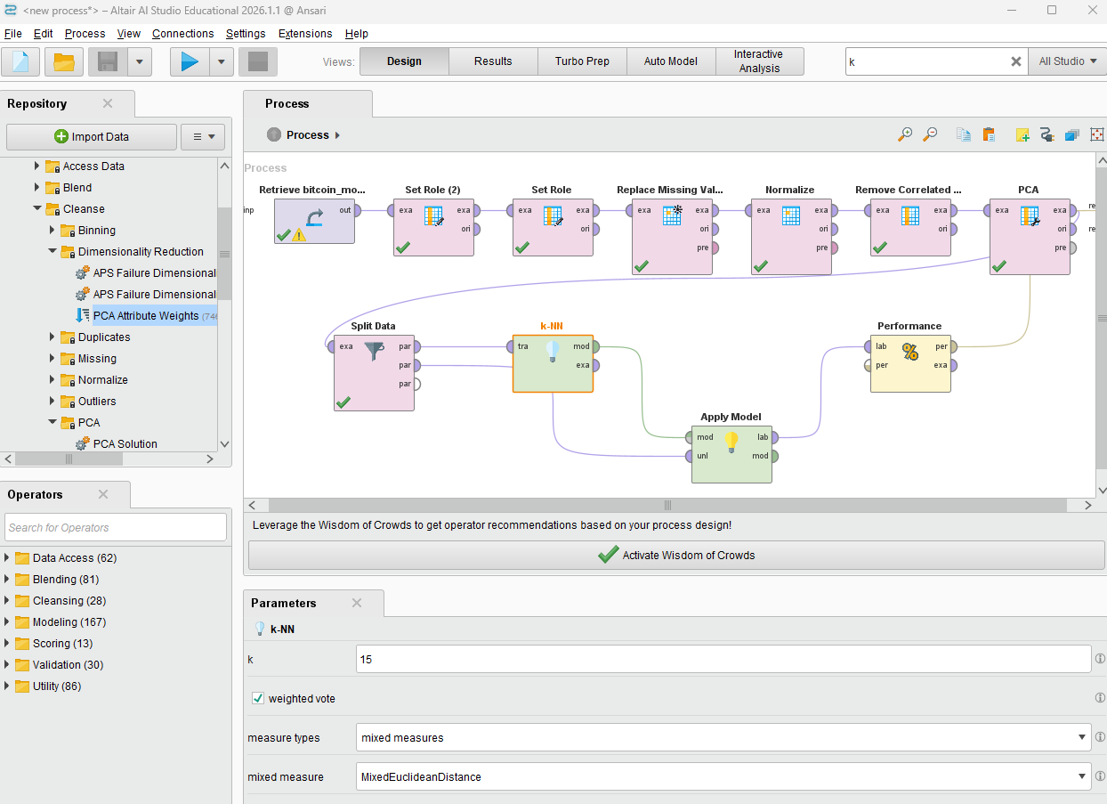

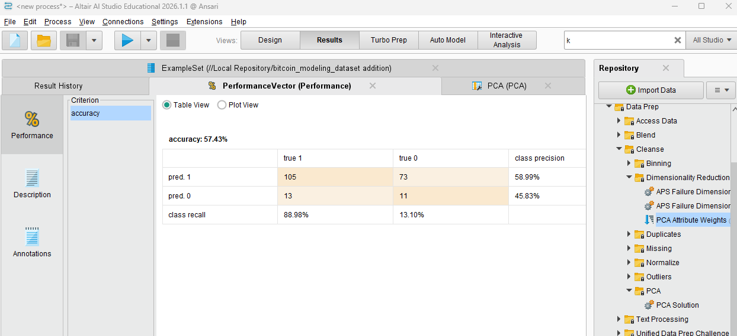
We connected the split data to the K-NN and the apply model. Next, we connected the decision tree to the apply model. After that, we connected the apply model to the performance and the performance to the “res”

Ensemble - Random Forest
A Random Forest Parameters:(200 trees, max depth 6) serves as the ensemble model, aggregating many decorrelated decision trees by majority vote to reduce variance and overfitting.
For each model, parameters were chosen by experimentation on the training/validation portion, and all three were evaluated on the identical held-out test set so the comparison is fair.
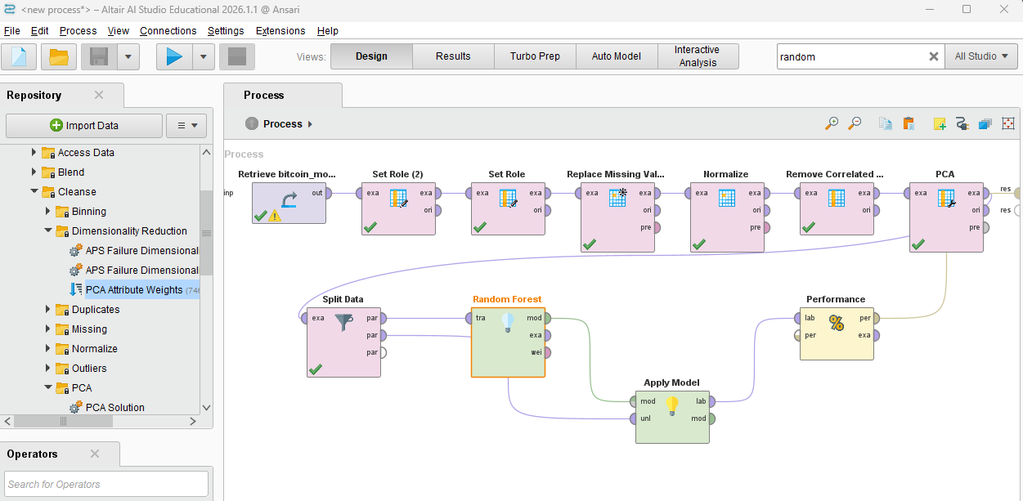

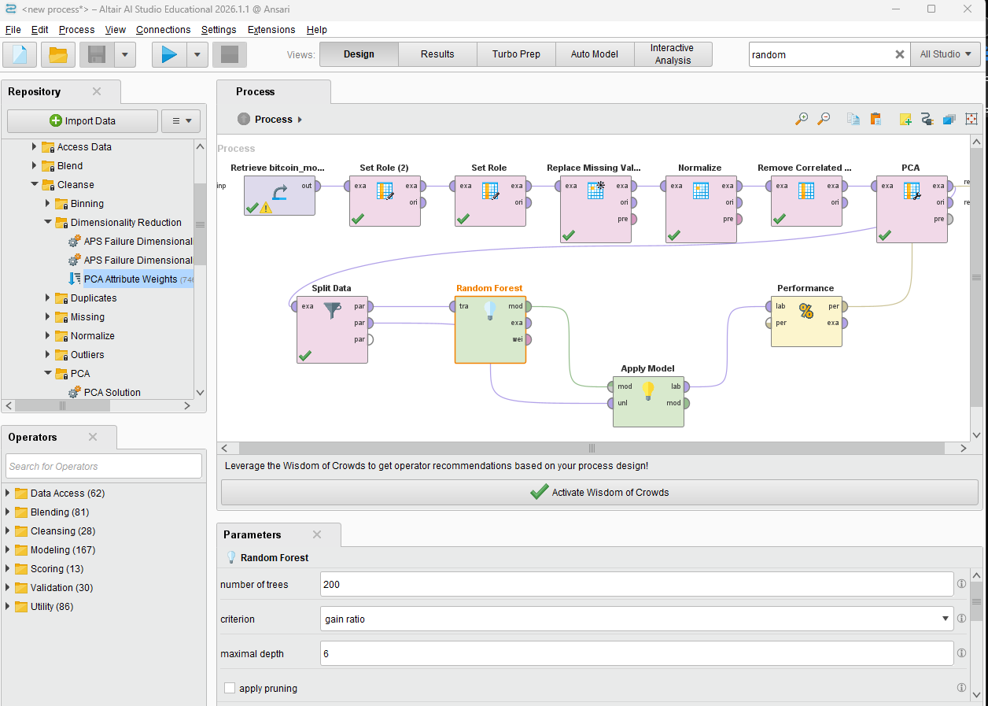
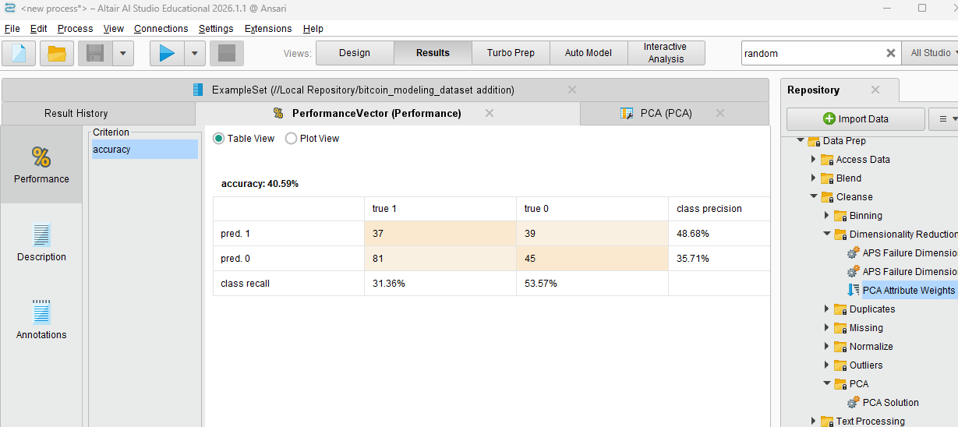
We connected the split data to the Random Forest and the apply model. Next, we connected the decision tree to the apply model. After that, we connected the apply model to the performance and the performance to the “res”

Task 5 - Evaluating Data Mining Models

Metrics Used & Justification
Because the classes are slightly imbalanced (baseline majority-class accuracy = 58.42%), accuracy alone may be misleading, so four metrics as well as the confusion matrix were used. Accuracy and precision is crucial because a false “Up” signal that predicts a rise that does not occur can directly cause a losing trade; recall captures how many authentic up-moves are caught; and F1 balances the two into a single number that is comparable.
Model | Accuracy | Precision (Class 1) | Recall (Class 1) | F-Measure
Decision Tree | 58.42% | 58.42% | 100.00% | 73.75%
k-NN | 57.43% | 58.99% | 88.98% | 70.95%
Random Forest | 40.59% | 48.68% | 31.36% | 38.16%

Model 1 Evaluation - Decision Tree
The Decision Tree achieved an accuracy and precision of 58.42%, correctly predicting market direction for 58 out of 100 days. Even though its recall is 100.00% and its F-measure is 73.75%, the confusion matrix reveals a flaw that this performance is due to the model guessing. The model predicted "1" (Up) for every single instance, failing to classify any "0" (Down) day. A 100% recall means no upward movements are missed however a model that just guesses the same direction will not be applicable or useful for trading and will expose a portfolio to downside risk.

Model 2 Evaluation - k-NN
The k-NN model achieved an accuracy of 57.43% (57 out of 100 days correct) and a precision of 58.99%. It was right about 59% of the times it predicted an upward trend. It caught 88.98% of the actual market upswings, resulting in a solid F-measure of 70.95%. Unlike the Decision Tree, k-NN attempts to classify both market directions. However, because its overall accuracy falls slightly below the 58.42% majority-class baseline, it fails to provide a statistical advantage and is not reliable for deployment.

Model 3 Evaluation - Random Forest
The Random Forest is the weakest model in this experiment with a low accuracy of 40.59% and a precision of 48.68%. Its recall is also low at 31.36%, meaning it missed around 69% of the upward market trends, culminating in the lowest F-measure of 38.16%. Despite being an ensemble method designed to reduce individual tree errors, it misclassified this PCA-reduced dataset and performed much worse than a guess, making it fully unsuitable for useage.

Models' comparison with Bar Chart
The decision tree was the best performing model as it achieved the highest accuracy percentage (58.42%) and the highest F-Measure percentage (73.75%)
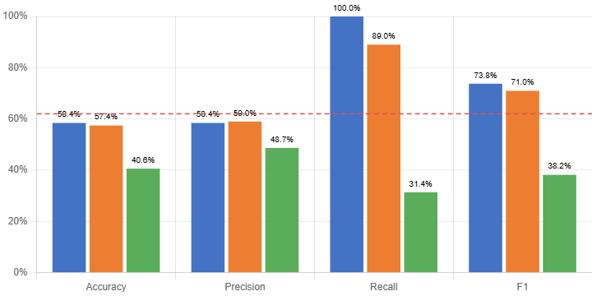
Decision tree KNN Random Forest (Ensemble)

Confusion Matrices
The confusion matrix across all three models has a strong tendency to identify "Up" market days (Class 1) due to the majority-class distribution in the test set. However, because of this trend, the models had difficulty in being accurate in predicting "Down" market days (Class 0).
Across all three models, k-NN performed the best because it was the only model that was able to identify a decent portion of both market directions, capturing $11$ actual down days and $105$ up days while maintaining a stable accuracy (57.43%). Conversely, the Decision Tree had guessed "Up" every day and completely missed the mark. The Random Forest had not done much better, classifying the trends poorly with an accuracy of only 40.59%. So, while still limited, k-NN comes out as the most balanced model for our analysis of market directions. Visualizations of the confusion matrices for all three models can be seen below.

Decision Tree
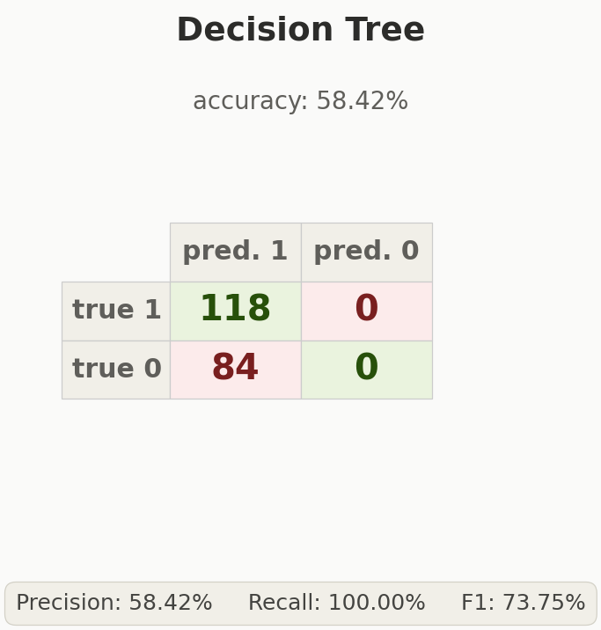

KNN
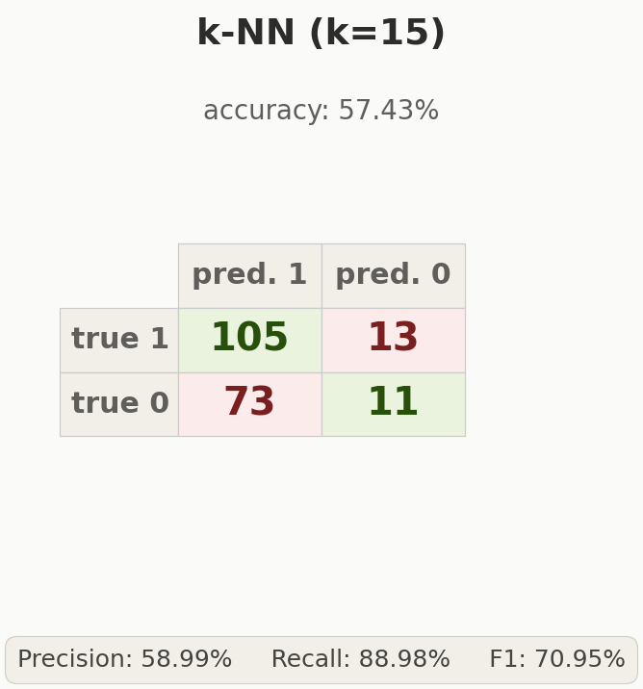

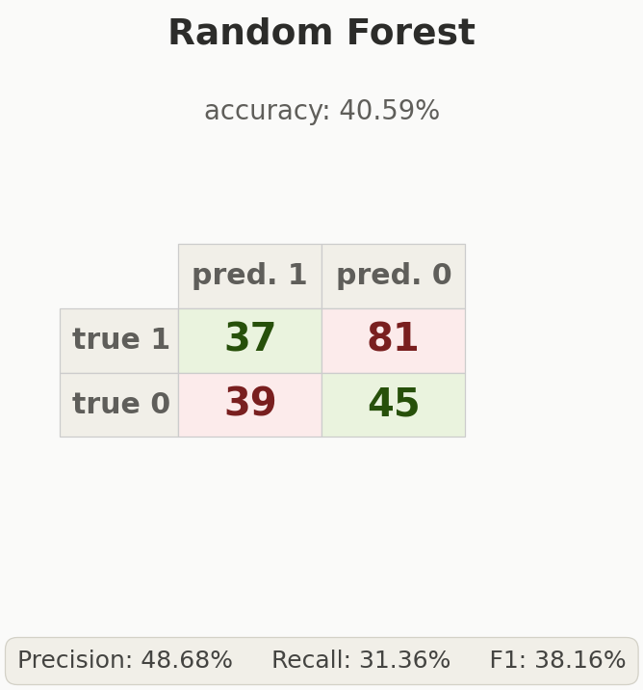
Random Forest

Interpretation: The Decision Tree predicts “UP” for every instance, gathering 118 true positives and zero true negatives, which hits 100% recall but its precision, at 58.42%, matches its accuracy. This isn't helpful due to it not improving discrimination, making it the weakest model out of the three.
k-NN (k=15) overall is the most balanced out of the three models. It correctly identified both Up days (105 TP) and some Down days (11 TN), yielding the highest F1 score of 70.95%. Its recall of 88.98% is very strong, though its precision of 58.99% remains humble, and it still heavily favors the majority class.
Random Forest is the most conservative model, predicting Down more often than the others (81 FN) resulting in the lowest recall from the three models at 31.36%. However, when it predicts Up, it achieves the highest precision among them at 48.68% which is still below the baseline. Its overall accuracy of 40.59% is the worst, and its F1 of 38.16% reflects a poor precision-recall trade-off.
Notably, none of the three models beat the majority-class baseline of 58.42% accuracy. The Decision Tree matches it by forcasting only the majority class, while k-NN and Random Forest are lower in accuracy. The models fail to have a meaningful predictive signal more than what a majority-class classifier would achieve showing it is difficult to forecast the Bitcoin price direction with the chosen feature set.

Task 6 - Inferences, Recommendation and Reflection

Compare & Contrast Models
Across all measures, k-NN (k=15) is the most balanced and usable model: it attempts to classify both market directions and achieves the highest F-measure (70.95%), although its accuracy (57.43%) sits just below the 58.42% majority-class baseline. The Decision Tree records the highest headline accuracy and F-measure (58.42% / 73.75%) only because it predicts “Up” for every single day it provides no real discriminative value. The Random Forest is the weakest performer at 40.59% accuracy, falling below the baseline. Going back to the problem statement, next-day Bitcoin direction is only weakly predictable from historical price/volume and blockchain data, and none of the models were able to convincingly beat the baseline. This is consistent with the heavy overlap between the Up and Down classes seen in the PCA analysis and aligns with the weak-form efficient-market view of liquid assets.

Inferences / Insights
- Price-level attributes were almost entirely redundant; the real (if weak) signal lives in returns, volatility and momentum indicators (RSI, MACD).
- PCA compressed 11 attributes to 7 components at ~97% variance, confirming the data has fewer truly independent dimensions than raw columns suggest.
- High-recall, low-precision behaviour (k-NN) shows that always predicting Up is a strong baseline during a bull market a warning about evaluating on trending periods.

Recommendations (Scope of Work)
- Adding alternative-data signals: news/social-media indicators, and macro indicators, which may carry signals that price history may lacks.
- Using sequence models (LSTM/GRU) and longer prediction horizons rather than next-day-only.
- Adopting rolling validation and including transaction costs in a realistic backtest before claiming any trading advantage.

Reflection
The most valuable lesson was that a clean methodology matters more than a high accuracy number. We enforced a chronological split and an honest baseline. The hardest parts were handling missing/redundant data and not being biased to tune toward a higher score to avoid being misleading. With more time we would engineer richer features as well as add sentiment data, and test deep-learning models. As a team we have divided the work across problem definition, data engineering, modelling, evaluation and reporting, and ensured every member understood not only their roles but our work as a whole.

References
- Altair. (2024). Altair AI Studio (formerly RapidMiner Studio) documentation. https://www.rapidminer.com/documentation/
- Breiman, L. (2001). Random forests. Machine Learning, 45(1), 5–32. https://doi.org/10.1023/A:1010933404324
- Fayyad, U., Piatetsky-Shapiro, G., & Smyth, P. (1996). From data mining to knowledge discovery in databases. AI Magazine, 17(3), 37–54.
- Han, J., Kamber, M., & Pei, J. (2011). Data mining: Concepts and techniques (3rd ed.). Morgan Kaufmann.
- Jaquart, P., Dann, D., & Weinhardt, C. (2021). Short-term bitcoin market prediction via machine learning. The Journal of Finance and Data Science, 7, 45–66. https://doi.org/10.1016/j.jfds.2021.03.001
- Jolliffe, I. T., & Cadima, J. (2016). Principal component analysis: A review and recent developments. Philosophical Transactions of the Royal Society A, 374(2065), 20150202. https://doi.org/10.1098/rsta.2015.0202
- McNally, S., Roche, J., & Caton, S. (2018). Predicting the price of bitcoin using machine learning. In 2018 26th Euromicro International Conference on Parallel, Distributed and Network-based Processing (PDP) (pp. 339–343). IEEE. https://doi.org/10.1109/PDP2018.2018.00060
- Mudassir, M., Bennbaia, S., Unal, D., & Hammoudeh, M. (2020). Time-series forecasting of Bitcoin prices using high-dimensional features: A machine learning approach. Neural Computing and Applications, 32, 18177–18193. https://doi.org/10.1007/s00521-020-05129-6
- Murphy, J. J. (1999). Technical analysis of the financial markets. New York Institute of Finance.
- Phauly. (n.d.). Get rich easily by following these simple steps [Kaggle notebook]. Kaggle. https://www.kaggle.com/code/phauly/get-rich-easily-by-following-these-simple-steps
- Rajkumar, S. (2018). Cryptocurrency historical prices [Data set]. Kaggle. https://www.kaggle.com/datasets/sudalairajkumar/cryptocurrencypricehistory
- Virk, D. S. (2017). Prediction of Bitcoin price using data mining [Master's thesis, National College of Ireland]. NCI Institutional Repository. http://norma.ncirl.ie/3079/
- Witten, I. H., Frank, E., Hall, M. A., & Pal, C. J. (2016). Data mining: Practical machine learning tools and techniques (4th ed.). Morgan Kaufmann.
- Yahoo Finance. (n.d.). Bitcoin USD (BTC-USD) historical data. Retrieved June 3, 2026, from https://finance.yahoo.com/quote/BTC-USD/history

Appendix
- GitHub repository link : https://github.com/DataMiningGroupproject/IT8416-Bitcoin-Data-Mining
- Video demonstration link : https://youtu.be/vfZMHG_hLUU
- RapidMiner process file / R scripts: IT8416_Bitcoin_Process.rmp
- Cleaned modelling dataset: bitcoin_modeling_dataset.csv

